**DAILY ONLINE ACTIVITIES SUMMARY**

|  |  |  |  |  |  |  |  |
| --- | --- | --- | --- | --- | --- | --- | --- |
| **Date:** | **19/06/2020** | | | | **Name:** | **Vandana E V** | |
| **Sem & Sec** | **8th A** | | | | **USN:** | **4AL15CS103** | |
| Online Test Summary | | | | | | | |
| **Subject** | | **BDA** | | | | | |
| **Max. Marks** | | **30** | | **Score** | | **26** | |
| Certification Course Summary | | | | | | | |
| **Course** | **Introduction to Digital Marketing** | | | | | | |
| **Certificate Provider** | | | **Great Learning Academy** | **Duration** | | | **2.5hrs** |
| Coding Challenges | | | | | | | |
| **Problem Statement:**  **1) Python program to print prime factors.** | | | | | | | |
| **Status: Solved** | | | | | | | |
| **Uploaded the report in Github** | | | | **YES** | | | |
| **If yes Repository name** | | | | **Vandana** | | | |
| **Uploaded the report in slack** | | | | **YES** | | | |

**OnlineTest Details:**

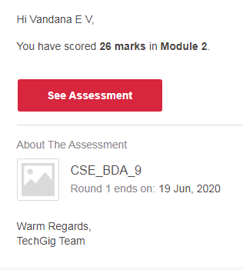

**Certification Course Details:**

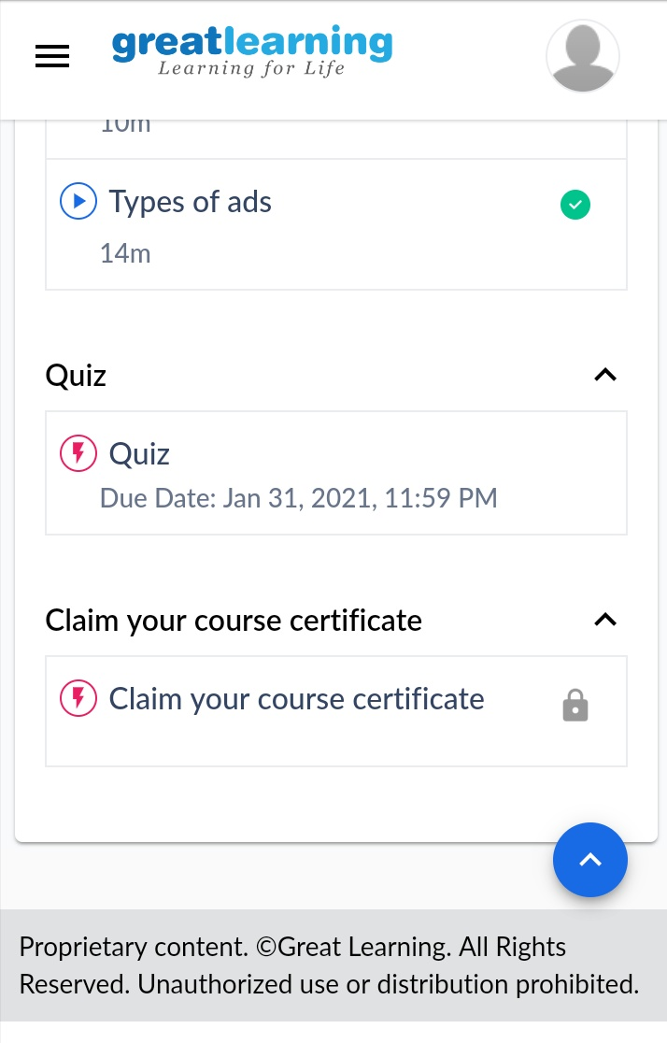

# CODE:

Program no:1

# Python program to print prime factors

import math

def primeFactors(n):

while n % 2 == 0:

print 2,

n = n / 2

for i in range(3,int(math.sqrt(n))+1,2):

while n % i== 0:

print i,

n = n / i

if n > 2:

print n

n = 315

primeFactors(n)